**Examining the Mechanical Characteristics of Sammaz-14 variety Maize Cob Nanofiber Reinforced in LDPD/LD-g-MAH/Org-MMT Nanocomposites**

**Jamila Baba Ali1, Abubakar B. Musa1, Abdullahi Danladi1, Bemgba B. Nyakuma2, Jamilu Usman3, Paul A.P. Mamza4, Zurina bint Mohamad5 and Ibrahim Shuaibu1**

1 Faculty of Engineering, Department of Polymer and Textile Engineering, Ahmadu Bello University, P.M.B 1044 Samaru, Zaria, Kaduna State, Nigeria.

2 Hydrogen and cell Laboratory, Institute of Future Energy, Universiti Teknologi Malaysia, 81310 Skudai, Johor, Malaysia.

3Interdisciplinary Research Center for Membrane and Water Security,

King Fahd University of Petroleum and Minerals, Kingdom of Saudi Arabia.

4Department of Chemistry, Ahmadu Bello University, P.M.B 1044 Samaru, Zaria, Nigeria.

5School of Chemical and energy Engineering, Department of Polymer Engineering, Universiti Teknologi Malaysia, 81310 Skudai, Johor, Malaysia.

**Corresponding author:** [**jamilahbabaali@gmail.com**](mailto:jamilahbabaali@gmail.com)

**ABSTRACT**

In this research, maize cob nanofiber of sammaz-14 variety which were extracted via the chemo-mechanical method (alkaline treatment and ball milling) are confirmed to be in nanoscale within the range of 1-100 nm by Atomic Force Microscopy (AFM) and Field Emission Scanning Electron Microscope (FESEM). They were used as reinforcing/functional filler with 2% organically modified montmorillonite (Org-MMT) as an additive and 3 % (low-density polyethylene grafted maleic anhydride) LD-g-MAH as compatibilizer in low density polyethylene (LDPE) to fabricate nanocomposites using injection moulding technique. Mechanical properties such as (Tensile strength, modulus, specific strength, Flexural strength, hardness, elongation and impact strength). Tensile strength increased up to 1.3 % at 2 % and modulus/ stiffness increased up to 200 % and 218 % at 5 % filler loading for maize cob nanofibre (MC-NF) and Nanoclay (Org-MMT) respectively. Strength-to-weight- ratio increase with increases in MC-NF and decreases with increase in nanoclay. Flexural strength and hardness also increase with increase in filler loading. However, steady decrease was observed for elongation at break and impact strength with an increase in filler loading.

**Keywords**: Nanocomposites, LDPE, MC-NF, Org-MMT, Mechanical properties,

**1.0 INTRODUCTION**

The wide abundance, accessibility, low cost, high fibre, absorbency and abrasiveness nature of Maize Cob (MC) has enhanced various agricultural and industrial applications such as animal feeds, mulching materials, contaminant adsorbents, remediation materials, solid biomass fuels and raw materials for the production of fine chemicals, Vanitjinda, and Sukyai, (2019); Vasudeva and Rangaswamy (2020). It is estimated that about 180 kg of MC is generated from 1000 kg of shelled which are sparsely utilized resulting in open-air burning, landfilling or dumpsite disposal as low-value solid wastes, which poses severe risks to human health, safety, and environment (Nnochiri and Adetayo, 2019; Elíaset al. (2019). One promising approach of adding value to MC is the extraction of nanocellulose through various chemical or mechanical processes.

The continuing search for high strength-to-weight ratio polymeric materials that meet performance requirements for demanding applications, has led to various research in the area of nanocomposites with different natural fibres and additives. The use of natural fiber in composites has recently gained more attention because of its biodegradability and recyclability, low cost, availability, abundance, low density, acceptable properties, and ease of production, among others. (Jai et a*l*. 2018; Ali et al. 2020; Seta et al. (2020)).

Behzad et al*.* (2017) reported on the influence of organically modified nanoclay and concluded that 1-5% of nanoclay is sufficient to positively modify the properties of polymer nanocomposites.

Fatima *et al.,*2015 and Mengual et al*.* 2017 investigated the effects of polyethylene-grafted maleic anhydride as compatibilizer they however reported 3% of PE-g-MAH is enough to reduce surface tension between the polymer and filler during composites processing.

The objectives of this study are to extract maize cob nanofiber and to use MC-NF as filler to fabricate nanocomposites with Low-density polyethylene, 3% LD-g-MAH, and 2% Org-MMT, to investigate the mechanical properties of the nanocomposites fabricated.

**2.0 Materials and Methods**

**2.1 Materials**

Montmorillonite (MMT) was acquired from Sigma Aldrich, Germany, Maize cobs (SAMMAZ-14 Maize cob variety) were obtained from the Institute for Agricultural Research, Federal Ministry of Agriculture and Rural Development. (IAR-ABU Zaria, Nigeria), planetary ball mill, Polyethylene (LDPE) grade no: H16178M170306D and LD-g-MAH (Orevac 18360) purchased from Lotte Chemicals, Johor, Malaysia, Brabenda two-roll-mill, Nissei horizontal plastic injection moulding machine and universal testing machine.

**2.2 Methods**

The Sammaz-14 maize cob nanofiber methodology of extraction: Maize Cob (MC)-75 µm were treated with 5 % NaOH for 4hrs at 95 oC under constant stirring of 225 rpm, rinsed to neutral, centrifuged at 8000rpm, decanted and freeze-dried at -50 oC in a freeze dryer followed by ball milling at 450rpm for 5hrs at room temperature. Nanofibre of 1-100 nanometre were obtained it has a crystallinity of 68 %. full method of extraction and other properties of MC are reported in Baba et al. (2020)

**2.3 Composites Preparation**

Table 1. Composite Formulations

|  |  |  |  |
| --- | --- | --- | --- |
| S/N | LDPE  (wt.%) | MC- LD-g-  NF (wt.%) MAH  (wt.%) | Org-  MMT (wt.%) |
| 1 | 100 | 0 0 | 0 |
| 2 | 94 | 1 3 | 2 |
| 3 | 93 | 2 3 | 2 |
| 4 | 92 | 3 3 | 2 |
| 5 | 91 | 4 3 | 2 |
| 6 | 90 | 5 3 | 2 |

**2.3.1 Compounding/Mixing**

The mixing/compounding was carried out using Brabender two-roll-mill with 150 g capacity at a temperature of 120 oC with a roller nip distance of 1.4mm and roller speed of 60 rpm for 20 min.

**2.3.2 Crushing/Granulating**

Plastic granulator SLM, 50 FY (Wenzhou Zhingang Co. Ltd China) was used for crushing the compounded samples to a smaller size, suitable for use on the injection moulding machine. The compounding and granulating or crushing was performed in the polymer processing lab at Universiti Tun Hussein Onn Malaysia.

**2.4 Fabrication/ Injection Moulding**

The crushed samples in the form of chips were fed into the Nissei horizontal Injection Moulding machine whose temperature was set at 120 oC, 140 oC and 160 oC, (for the hopper, barrel i.e heating and mixing chamber and the nozzle temperature respectively) after a complete cycle, the moulded samples were ejected from the mould cavity by the ejector pins. Moulding was carried out in a semi-automatic mode, the complete processes happened in approximately 10min/cycle. The fabricated samples were conditioned according to ISO 291 before characterization.

**2.5 Characterization of Fabricated Nanocomposites**

**2.5.1 Mechanical properties**:

Tensile tests were done using the universal tensile testing machine which was loaded with 5KN at room temperature according to ISO 527-2, with a crosshead speed of 2mm/min. An average of ten (10) samples were analysed and recorded accordingly.

The flexural test was performed according to ISO178-2003 and the hardness test were characterized according to ASTM 2240.

**3.0 Results and Discussion**

**3.1 Tensile Strength of LDPE/MC-NF and LDPE/nanoclay composites**

Figure 1 depicts Tensile strength results for LDPE/MC-NF composites against filler loading**.**

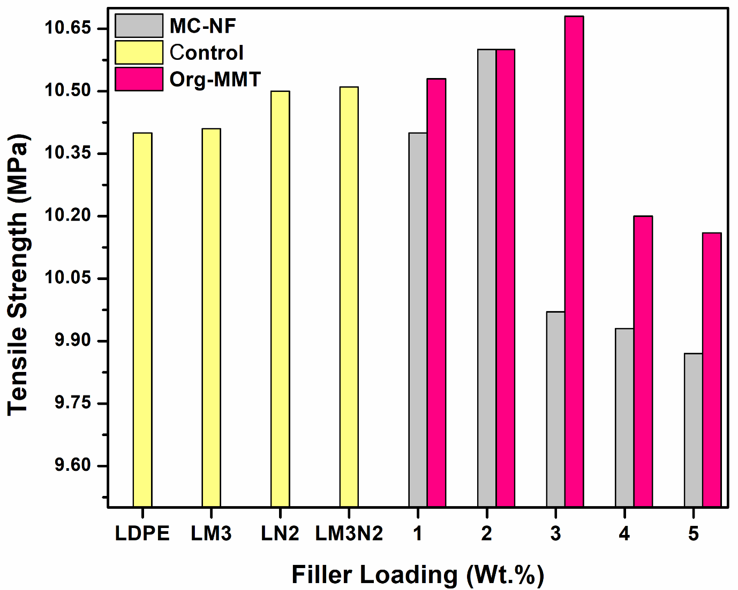

Figure 1: Tensile strength of LDPE/MC-NF and LDPE/nanoclay composites as a function of filler loading

KEY: LM3N2 = L= LDPE, M3= 3 % Maleic anhydride, N2= 2 % Nanofiber

From the results, it was observed that the tensile strength significantly increased as the filler loading (MC-NF and nanoclay) increased in LDPE up to 3 % filler loading and decreased gradually from 4 % to 5 %. It was found that, by adding 1 %, 2 %, 3 %, 4% and 5 % of MC-NF in 2% Org-MMT/ 3% LD-g-MA in LDPE, the tensile strength of nanocomposites increased steadily up to 3% filler loading. The increase in tensile strength of the nanocomposites compared to the neat LDPE could be attributed to the nucleating effect of LD-g-MA, which may have created strong interfacial adhesion and also reduced interfacial tension between the fillers and matrix creating adhesion, and compatibility between systems containing a hydrophilic filler and hydrophobic polymer or due the Intercalating/ exfoliating effects of nanoclay-Org-MMT which enhanced dispersion and compatibility and reduces voids formation in the system resulting to improved mechanical properties and dimensional stability.Some crucial factors affecting the mechanical properties of fibre-reinforced composite is the polymer/polymer interfacial tension and fibre/ matrix interfacial bonding/ adhesion, these are determined by several factors such as the nature of the polymer, fibre components/properties, the processing and fabrication methods, product design and fibre treatments i.e., chemical or mechanical treatments (Kamarudin *et al*., 2018).

**3.2 Tensile Modulus** **of LDPE/MC-NF and LDPE/nanoclay composites**

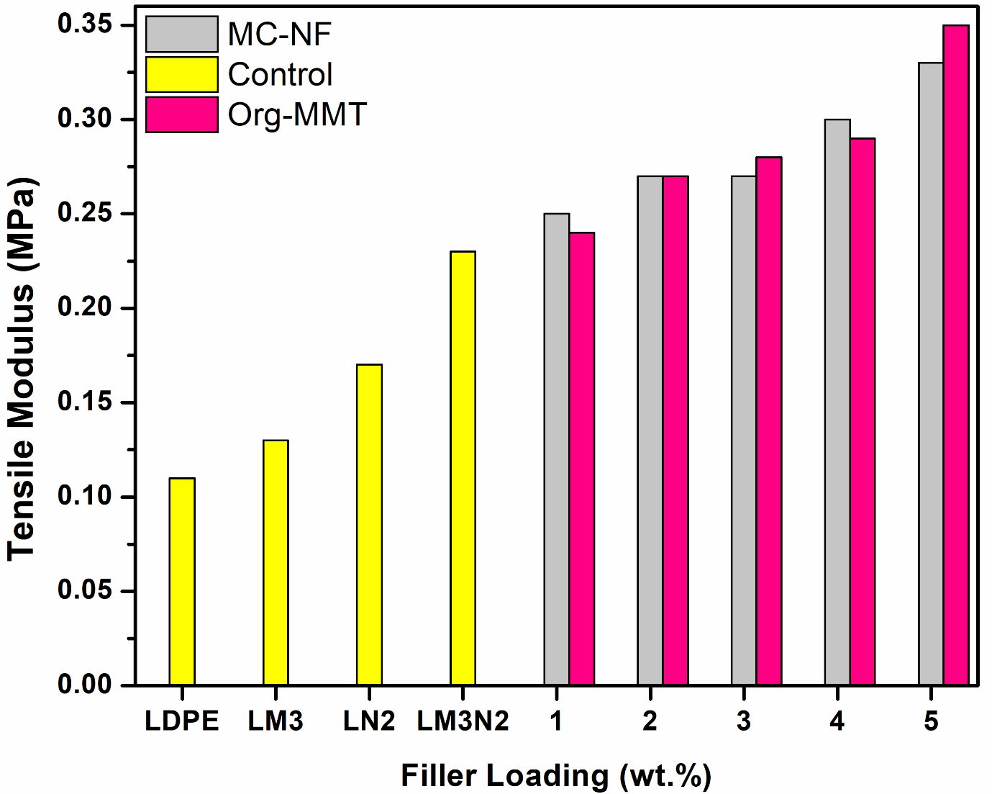

Figure 2: Tensile modulus of LDPE/MC-NF and LDPE/nanoclay composites as a function of filler loading

Figure 2. Showed an increase in modulus with an increase in filler content for both MC-NF and nanoclay. the material has remarkably increased in its stiffness up to 200 % for 5 % LDPE/MC-NF and 218 % for 5 % LDPE/nanoclay composites samples.

The improvement in modulus/stiffness may indicate an improvement in the effectiveness of oriented cellulose fibre due to the removal of hemicellulose, lignin and another non-cellulosic component in cellulose which led to better packing of cellulose chains. As a result, the fibres become relatively stiffer after the removal, this may have been attributed to the increase in stiffness of these composites. Similar findings of increase in stiffness with the addition of maleic anhydride were reported by Eszer and Ishak (2017), in their studies on the effect of compatibiliser on properties of starch-grafted-polypropylene/kenaf fibres composites where they reported an increase in tensile strength and modulus with increase in MA content up to 3 % which was attributed to interfacial compatibility and good dispersion of the fillers in the matrix structure.

**3.3 Specific Strength** **of LDPE/MC-NF composites**

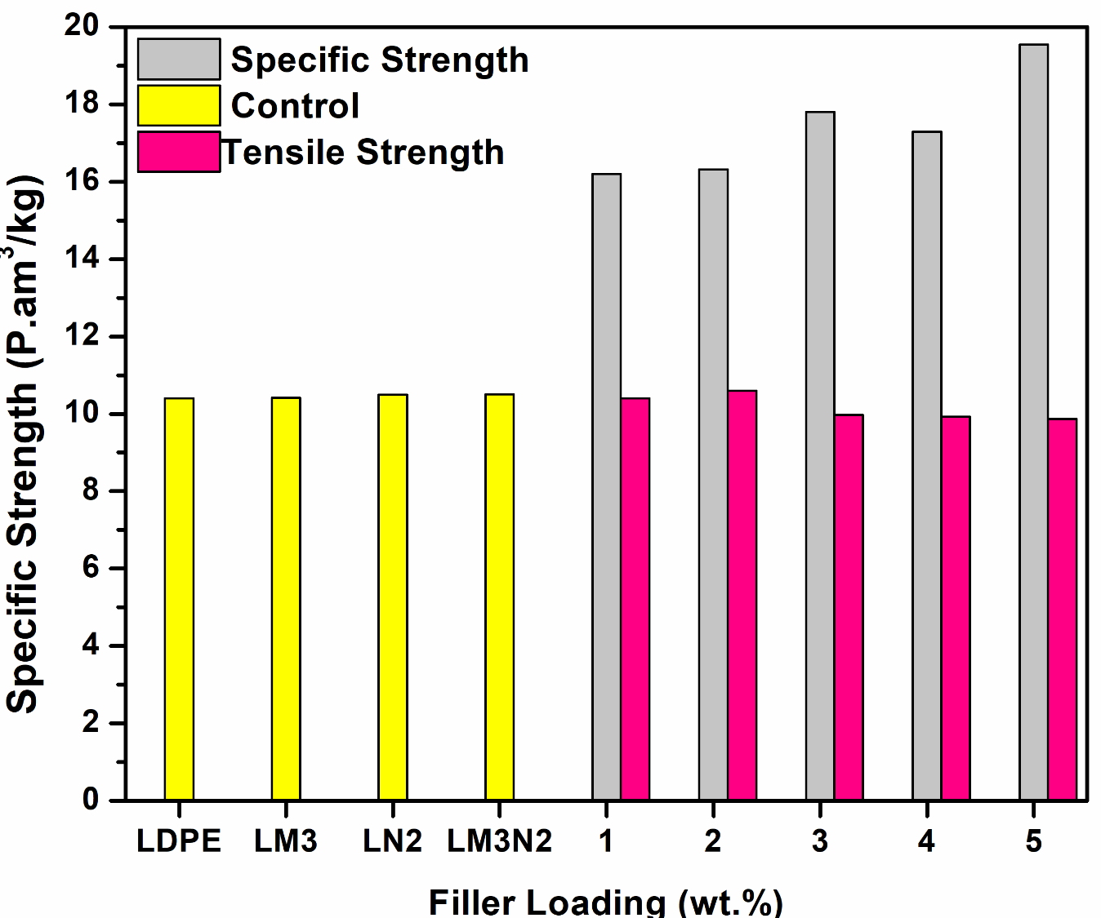

Figure 3: Specific strength and tensile strength of LDPE/MC-NF composites as a function of filler loading

Figure 3 and 4. Showed specific strength of LDPE/MC-NF and LDPE/nanoclay composites respectively, in relation to its ultimate tensile strength. Specific strength or strength-to-weight- ratio is the strength of the composites divided by its density. From the results, it is observed that the specific strength of the composite is higher than its tensile strength and pure LDPE for both MC-NF and nanoclay composites

**3.4 Specific Strength of LDPE/nanoclay composites**

Figure 4: Specific strength and tensile strength of LDPE/nanoclay composites as a function of filler loading

Figure 3 and 4. Showed specific strength of LDPE/MC-NF and LDPE/nanoclay composites respectively, in relation to its ultimate tensile strength. Specific strength or strength-to-weight- ratio is the strength of the composites divided by its density. From the results, it is observed that the specific strength of the composite is higher than its tensile strength and pure LDPE for both MC-NF and nanoclay composites. However, the specific strength decreased as the filler content increased due to the decrease in tensile strength and increase in density with the incorporation of fillers up to 5 % loading, Contrary to the LDPE/nanoclay composites, the specific strength for LDPE/MC-NF increased with increase in filler content from (10.4 – 19.54 Pa.m3/kg up to 47 % increment at 5 % loading) which could be due to the lower density recorded for the LDPE/MC-NF composites samples. Generally, the specific strength recorded for all the composites is higher than the tensile strength reported making it perfect for some engineering applications where strength-to-weight-ratio is to be considered. However, the LDPE/MC-NF composites recorded higher specific strength which could be due to the higher strength of MC-NF or its low density as compared with the density of the nanoclay and /or the better reinforcing effects of MC-NF in the matrix. It was reported by (Peng et al. 2008) that materials with high strength and low mass density provide a high specific strength and are ideal for engineering applications. The study of specific strength is essential in the design of efficient and safe structures. Especially when the design is strength-driven. Material with high specific strength is developed to meet the requirements of advancing technology, these materials are usually used in automobile and aerospace applications Brown and Adam, (2012).

**3.5 Elongation at Break** **of LDPE/MC-NF and LDPE/nanoclay composites**

Figure 5 depicts the elongation of the fabricated composites. the percentage elongation is denoted by ε = (∆L/L) x100. This behaviour reveals the ductility of a material.

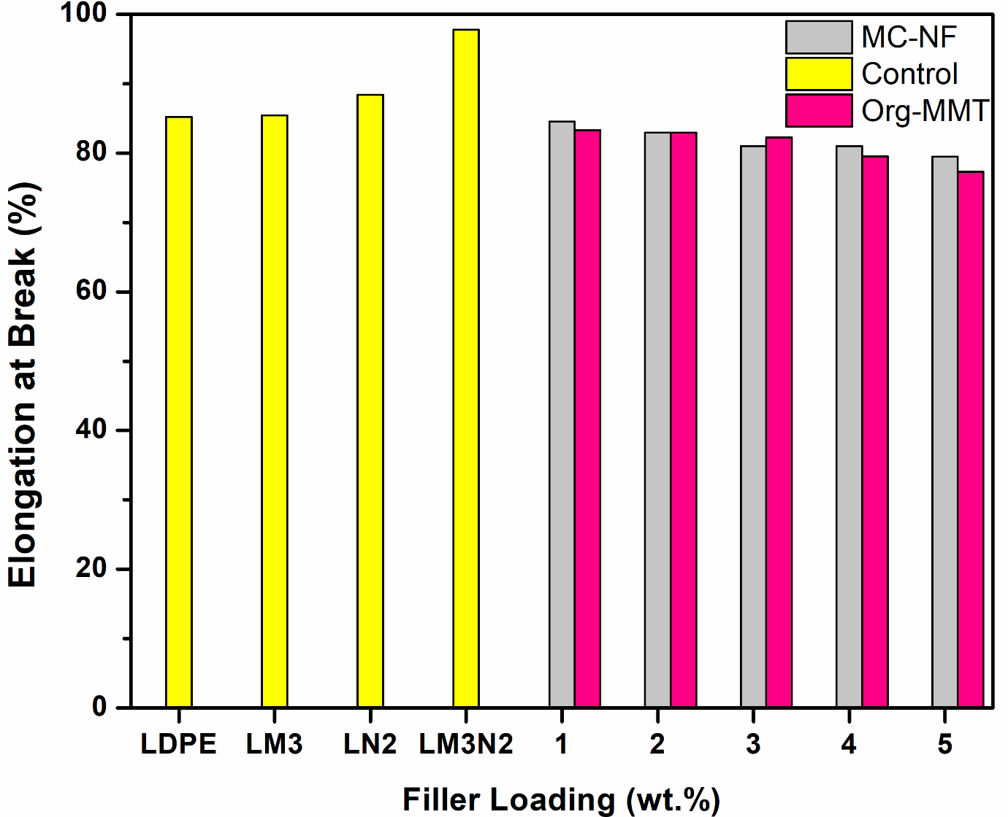

Figure 5: Elongation at break as a function of filler loading

The addition of fillers resulted in decrease in the ductility of these composites for both LDPE/nanoclay 10.21 % and LDPE/MC-NF 7.22 % at 5 % filler content respectively. The increase in filler loadings from 1-5 % in the polymer matrix resulted in the stiffening and hardening of the composites which reduced its ductility, and led to lower elongation properties. Reduction in elongation at the break of polymer/fibre composites with increase in filler content, irrespective of filler particle size and length has been reported by Mat Taib et al. (2010). Other studies have reported a decrease in elongation at break with an increase in filler loading (Fatimah et al*. 2*015; Adamdu et al. 2020). The decrease was attributed to the fact that fillers cause polymer matrices to lose their elastic properties due to the stiffening effect which leads to the restriction of polymer chain mobility Ali et al. (2020) also reported that with an increase in filler content, the matrix quantity also reduces, which consequently reduces the effect of the matrix as compared to that of the filler this then leads to an increase in modulus of composites but decrease in elongation at the break this could be the reason for decrease in elongation observed herein.

**3.6 Flexural strength of LDPE/MC-NF and LDPE/nanoclay composites**

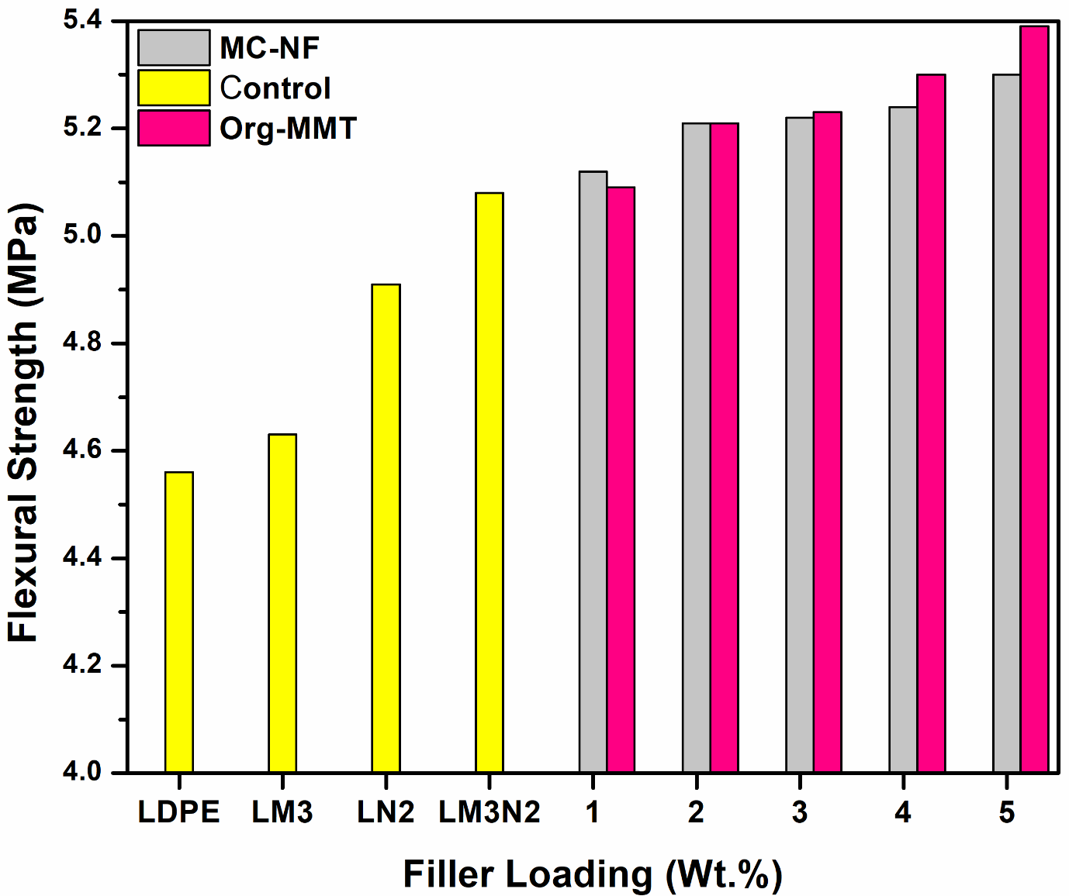

Figure 6: Flexural strength of LDPE/MC-NF and LDPE/nanoclay composites as a function of filler loading.

The flexural strength of the LDPE matrix and its composites showed general improvement with the increase in filler loadings for LDPE/MC-NF and LDPE/nanoclay composites. However, the composites of LDPE/nanoclay showed higher flexural strength when compared to the composites of LDPE/MC-NF the results showed a similar trend with the tensile strength and modulus of the same composites. The addition of 1 % to 5 % of MC-NF increased the flexural strength from 4.56 MPa for pure LDPE to 5.12 MPa (12.28 %) and 5.30 MPa (16.22 %) for 1 % and 5 % of MC-NF loading respectively. The addition of 1 % to 5 % of nanoclay also increased the flexural strength to 5.09 MPa (11.62 %) to 5.39 MPa (18.20 %) for 1-5 % of nanoclay loading, respectively. The general strength of natural fibre-reinforced composites solely depends on the properties of its constituent’s material, treatments applied, processing conditions as well as the interface interaction (Alireza and Amir 2010). When considering the flexural properties of natural fibre reinforced polymer composites, homogeneity of the overall composites needs to be considered because of the bending action the material will undergo during usage. Similar improvement in flexural strength and modulus/stiffness was reported by Fairuz et al. 2016; Eszer and Ishak, (2017), they attributed the improvement to the better interface between the fibre and the matrix. Ibrahimet al., 2012; Koutsomipolouet al. 2014 reported deviation from these findings, they reported a decrease in flexural strength with filler loading they attributed the decrease to be due to poor surface adhesion between polymers and fibre and poor resin fibre interpenetration at the interface.

**3.7 Impact strength of LDPE/MC-NF and LDPE/nanoclay composites**

Figure 7: Impact strength of LDPE/MC-NF and LDPE/nanoclay composites as a function of filler loading

From Figure 7, it could be observed that, Impact strength of the composites decreased with an increase in filler loading for both (MC-NF and nanoclay) in LDPE. It has been reported that the addition of filler into the polymer matrix increases the probability of filler forming clumps/aggregates, which may result in regions of stress concentration requiring less energy for crack initiation (MatTaibet al. 2010; Ali et al. 2020). The results of impact strength for LDPE/MC-NF and LDPE/nanoclay composites in Figure 7. depicted that the pure LDPE an exhibited higher impact strength of 2.55 J/m while its corresponding composites exhibited lower impact strengths. The impact strength decreased from 1.32 J/m and 1.26 J/m at 1 % filler loading to 0.82 J/m and 0.53 J/m at 5 % filler loadings for LDPD/MC-NF and LDPE/nanoclay composites respectively. Contrary to flexural and tensile properties which showed an increase in strength with filler addition, impact strength steadily decreased with the incorporation of fillers (MC-NF and nanoclay). The decrease was more obvious in the composites with nanoclay as the composites became more brittle with the addition of nanoclay into the matrix. The decrease in impact strength observed in these composites could be attributed to the fact that a polymer matrix with high filler content has less ability to absorb shock or impact energy because fillers disturb matrix continuity and individual filler is a site of stress concentration especially at high content, which can act as a micro-crack initiator for propagation of failure.

**3.8 Hardness of LDPE /MC-NF and LDPE/nanoclay composites**

Figure 8: Hardness of LDPE /MC-NF and LDPE/nanoclay composites as a function of filler loading.

Figure 8, Shows the variation of hardness with percentage filler loading for the prepared composites. The results showed an appreciable general increase in hardness with an increase in filler loading for both the LDPE/MC-NF and LDPE/nanoclay. The increment occurred progressively from 1 and 5 % MC-NF and nanoclay contents. The incorporation of natural fillers into polymer matrices causes substantial changes in the mechanical properties of the resulting composites. The mechanical properties of composites reinforced by particles generally depend on the dispersion /distribution state, interfacial adhesion between particles and matrices, morphology and particle loading of the fillers (Essabir et al. 2013a). Results for hardness of LDPE /MC-NF and LDPE/nanoclay composites as a function of filler loading also showed an appreciable increase in the hardness of the composites from 47.30 to 49.85 (shore D) for LDPE /MC-NF at 3 % filler content and later dropped to 48.00 shore D (1.5 %). Results for LDPE/nanoclay depicted increment in the resistance of the composites to surface indention and scratch with an increase in nanoclay content from 1 to 5 % filler loading from 47.30 to 51.10 (shore D), 3.8 %, 4.4 %, 5.3 %, 6 % and 8 % for 1-5 % filler loading, respectively. These results show that nanoclay contributed positively to the hardness of LDPE/nanoclay composites by tailoring and enhancing the properties of LDPE hence improving the hardness of the composites.

This could be attributed to the proper dispersion of the fillers in the matrix structure which minimizes the formation of voids, and reduces surface tension hence, resulting in stronger surface bonding between these fillers and the matrix, resulting in improved mechanical properties.

**CONCLUSION**

Nanocomposites of MC-NF/LDPE were successfully fabricated and characterized. It was observed that the mechanical properties: Tensile strength, tensile modulus, specific strength, flexural strength and hardness of the composites increased with an increase in filler (MC-NF and Nanoclay) content up to 3 % and decreased with filler incorporation. However, impact strength, shows the ability of the composite to absorb shock decreased steadily with increase in filler loading. The ductility of the nanocomposites also decreased a with increase in filler loading. The fabricated nanocomposites of maize cob nanofiber, nanoclay, MA-g-PE with polyethylene (LDPE) appears to be a good way of obtaining a bio-friendly engineering material with excellent mechanical properties which can be used where moderate strength is required e.g in building (partition walls, shelves, staircase handle roof decker) as well as the automotive interior (brakes, doors, seats, dashboard, etc.)

ORCID

Jamila B. Ali http://orcid.org/0000-0001-7772-3395

Abubakar B. Musa http://orcid.org/0000-0003-0085-0825

Bemgba B. Nyakuma <http://orcid.org/0000-0001-5388-7950>

Jamilu Usman <https://orcid.org/0000-0002-3800-423X>

**Reference**

Adamu, M., Md.Rezaur, R and Sinin, H. (2020). Bamboo Nanocomposites: Impact of Poly (Ethylene-alt-Maleic Anhydride) and Nanoclay on Physicochemical, Mechanical and Thermal Properties. *Bio Resources*, 15(1), 331-346.

Alireza, A and Amir, N. (2011). Preparation and Characterisation of Polypropylene/Wood Flour/Nanoclay composites. *European Journal of Wood and Wood Products*, 69(4), 663-666

Ali, J. B., A. B. Musa., A. Danladi, M. M., Bukhari, and B. B., Nyakuma.(2020). Physico-Mechanical Properties of Unsaturated Polyester Resin Reinforced Maize Cob and Jute Fibre Composites. *Journal of Natural Fibres*, 1–21. doi:10.1080/15440478.2020.1841062

Behzad, K., Pouria, R and Nadir, A. (2017). Influence of organically modified nanoclay on the thermal and combustion properties of bagasse reinforced HDPE Nanocomposites. *Journal of polymer environment*, 25,1198–1207.DOI. 10.1007/s10924-016-0897-x

Brown, R. Adam. (2012). Tensile Strength and the Mining of Black Holes. *Physical Review Letters,* 111(21), Retrieved from https://arxiv:1207.3342

Dufresne, A. 2017. Nanocellulose: From nature to high-performance tailored materials. Berlin, Germany: Walter de Gruyter GmbH & Co KG.

Ekpa, O., Palacios, R., N., Kruseman, G., Fogliano, V and Linnemann, A. R. (2019). Sub-Saharan African Maize-Based Foods-Processing Practices, Challenges and Opportunities. *Food Reviews International,* 35, 609-639.

Elías, R. D. P., Gabriela, T.N., Ana, L. S. H., Luis, R. O. S., João, L. B., Andrea C.C and Fabio, M. Y. (2019). Thermogravimetric and FTIR Analysis of Corn Cob Pyrolysis. *Nota Tecnica*, 42(5), 566-569. <http://dx.doi.org/10.21577/0100-4042.20170360>

Essabir, H., Hilali, E., Elgharad, A., Minor, H. E., Imad, A and Elamraoui, A. (2013a). Mechanical and thermal properties of composites based on polypropylene reinforced with Nut-shells of Argan particles. *Materials and Design*, 49, 442-448.

Eszer, N.H and Ishak, M.A. (2017). Effect of Compatibilizer on Morphological, Thermal and Mechanical Properties of Starch-Grafted Polypropylene/Kenaf Fibres Composites. *IOP Conference Series Materials Science and Engineering* 368(1):012017. DOI:10.1088/1757=899X/368/1/012017

Fairuz, A.M., Sapuan, S.M., Zainudin, E.S and Jaafar C.N.A. (2016). Effect of filler loading on mechanical properties of pultruded kenaf fibre reinforced vinyl ester composites. *Journal of Mechanical Engineering and Sciences,*10(1),1931-1942, DOI: <http://dx.doi.org/10.15282/jmes.10.1.2016.16.0184>

Fatimah A.R.H, Supri A.G and Firuz. Z (2015). The Effect of Polyethylene-grafted-Maleic Anhydride as Compatibilizer on Properties of Recycled High-Density Polyethylene/Ethylene Vinyl Acetate/Taro Powder (Colocasia esculenta) Composites. *Journal of Advanced Research in Materials Science*. ISSN (online): 2289-7992 | Vol. 10, No.1. Pages 26-39.

Hameed. N, Thomas S.P, Abraham R, Thamos S (2007). Morphology and Contact Angle of Poly(styrene-co-acrylonitrile) Modified Epoxy Resin Blends and their Glass Fibre Reinforced Composites. Express polymer letters. vol. 1, No 6, pp345-355. Doi:10.3144/expresspolymlett.2007.49

Ibrahim, M.S., Sapuan, S.M., and Faieza, A.A. (2012). Mechanical and thermal properties of composites from unsaturated polyester filled with Oil Palm Ash. *Journal of Mechanical Engineering and Sciences, 2*: 133-147.

Jai Inder Preet Singh, Sehijpal Singh and Vikas Dhawan (2018). Effect of Curing Temperature on Mechanical Properties of Natural Fiber Reinforced Polymer Composites. Journal ofNaturalFibers.Pp687-696,Volume15, <https://doi.org/10.1080/15440478.2017.1354744>

Kamarudin, S.H., Abdullah, L.C., Aung, M.M and Ratnam, C.T. (2018). A Study of Mechanical and Morphological Properties of PLA Based Bio composites Prepared with EJO Vegetable Oil Based Plasticiser and Kenaf Fibres. *Wood and Biofibre International Conference* (WOBIC2017).5(8), DOI: 10.1088/2053-1591/aabb89

Koutsomitopoulou, A.F., Bénézet, J.C., Bergeret, A and Papanicolaou, G.C. (2014). Preparation and characterisation of olive pit powder as a filler to PLA-matrix composites. *Powder Technology*, 255, 10-16.

Mat Taib, R., Ramarad, S., Mohd-Ishak, Z. A., and Todo, M. (2010). Properties of Kenaf Fibre/Polylactic Acid Biocomposites Plasticized with Polyethylene Glycol. *Polymer Composites, 31*(7), 1213-1222.

Mengual. A, Juarez. D, Balart. R and Ferrandiz. S. (2017).PE-g-MA, PP-g-MA and SEBS-g-MA Compatibilizers used in Material Blends. *Conference Proceeding: MESIC 2017, 28-30 JUNE 2017, Vigo (Pontevedra*), Spain.

Nnochiri, E. S., and O. A. Adetayo. 2019. Geotechnical properties of lateritic soil stabilized with corn cob ash. Acta Technica Corviniensis-Bulletin of Engineering 12:73–76.

Peng, H., Chen, D and Huang, J.Y. (2008). Strong and Ductile Colossal Carbon Tubes with Walls of Rectangular Micropores. *Physical Review Letters,*101(14). Doi:10.1103/physrevlett.101.145501

Phanthong, P., G. Guan, Y. Ma, X. Hao, and A. Abudula. 2016. Effect of ball milling on the production of nanocellulose using mild acid hydrolysis method. Journal of the Taiwan Institute of Chemical Engineers 60:617–22. doi:10.1016/j. jtice.2015.11.001.

Phanthong, P., P. Reubroycharoen, X. Hao, G. Xu, A. Abudula, and G. Guan. 2018. Nanocellulose: Extraction and application. Carbon Resources Conversion 1 (1):32–43. doi:10.1016/j.crcon.2018.05.004.

Saelee, K., N. Yingkamhaeng, T. Nimchua, and P. Sukyai. 2016. An environmentally friendly xylanase-assisted pretreatment for cellulose nanofibrils isolation from sugarcane bagasse by high-pressure homogenization. Industrial Crops and Products 82:149–60. doi:10.1016/j.indcrop.2015.11.064.

Seta, F. T., X. An, L. Liu, H. Zhang, J. Yang, W. Zhang, S. Nie, S. Yao, H. Cao, and Q. Xu. 2020. Preparation and characterization of high yield Cellulose Nanocrystals (CNC) derived from ball mill pretreatment and maleic acid hydrolysis. Carbohydrate Polymers 234:115942. doi:10.1016/j.carbpol.2020.115942.

Vasudeva Nayaka, K., and B. Rangaswamy. 2020. Pulverized maize cob as a recycled agro waste-a feasibility study. International Journal of Waste Resources 10:376.

Vanitjinda, G., Nimchua, T and Sukyai, P. (2019). Effect of Xylanase-Assisted Pre-treatment on the Properties of Cellulose and Regenerated Cellulose Films from Sugarcane Bagasse. *International Journal of Biological Macromolecules*, 122:503-516.